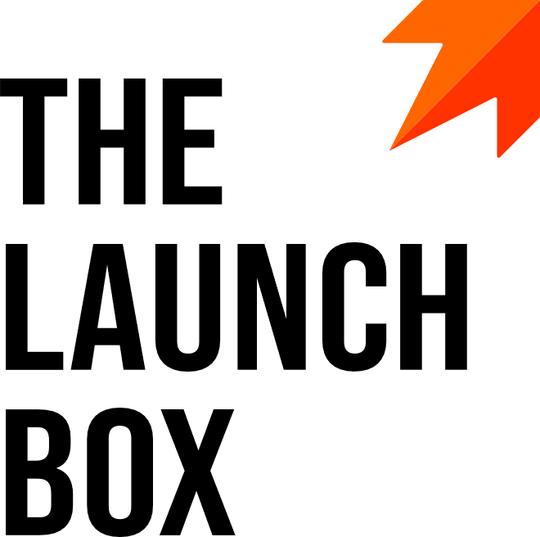

Job Title: Front-End Developer / Full-Stack Developer

Seniority Level: Mid-level, Junior, Entry. Senior

Job Location: Guadalajara, MX

Employment Type: Full time

Travel: Up to 30%

The Launch Box, LLC is the engine for the fastest growing and most successful new professional services firms. The Launch Box provides investment capital, strategic advice, comprehensive services, and turnkey systems to accelerate the launch-to-scale-to-exit timeline and reduce risk for new founders. With an expert team and variable cost structure, we increase the probability of success while building valuable, sustainable, and marketable businesses.
The Launch Box is seeking a Full-Stack Developer to join our latest client – an exciting new cloud software development firm in Guadalajara. In this role, you will develop innovative cloud solutions for clients in diverse sectors. This includes but is not limited to…

What You Will Do (Responsibilities):
- Responsible for
- Manage
- Provide
- Create, manage and monitor
- Implement
- Develop
- Support

Skills, Qualifications and Requirements:
- Degree in Computer Science, Computer Technology & Networking, IT, or related discipline preferred or 4+ years of equivalent working experience
- 3-5 years of experience with
- Considers communication style based on audience and remote vs. in-person environment
- Strong attention to detail and exceptional customer service, teamwork, and collaboration skills
- Ability to multitask and prioritize in a high change environment
- Willingness and ability to travel up to 30% of the time
- Ability to successfully manage working between the USA and Mexico
- Advanced/professional English communication skills, both verbal and written
- Only resumes submitted in English will be considered

We foster both personal and professional growth. We offer a competitive salary set according to your experience. We provide major health and life insurance plans with the option to enroll in our competitive medical check-up and car insurance policies. We have additional generous benefit offerings including employer contributions to a savings fund, performance-based bonus, flexible time off, and an extended maternity/paternity leave. We value diversity, inclusivity, and supporting our employees so they can enjoy all aspects of life.
The above statements are intended to describe the general nature and level of work being performed by people assigned to the job. They are not intended to be an all-encompassing list of all responsibilities, duties, and skills required of personnel so classified. Reasonable accommodations to essential functions of the job will be made if necessary.

